A PROJECT REPORT ON
MCOMP Relay Testing and DAP-HMI

SUBMITTED BY
Miss. Sruti Jain
Miss Nimisha Gupta

UNDER THE GUIDANCE OF
Mr. Shibu Jolly

Larsen & Toubro Limited
Powai Campus
Saki Vihar Road
Mumbai-400072

Acknowledgement
The authorship of a monograph usually attributes to one person, but a report on the internship such as this must thank multiple individuals. We take this opportunity to express our sincere gratitude to all those who have helped us in making our internship at Larsen & Toubro Ltd., a valuable learning experience. First, we would like to thank our Company Mentor Mr. Shibu Jolly for sparing valuable time to constantly monitor and guide our progress. He has been a constant source of inspiration throughout the internship. Moreover, we would like to thank the employees at Larsen and Toubro for their constant guidance and help to find the strategic fit between our findings and the company’s ways of working. This has not only helped us make a more sincere effort towards making this internship as practical in application as possible, but has also helped us identify some very crucial parameters for data analysis and dealer surveys. This acknowledgement would be incomplete without thanking Mr. Rahul D. Kulkarni, for acting as a central pivot of knowledge and guidance during this internship. Finally, we express my gratitude to the every person who has devoted their valuable time in accomplishing my summer internship project.
-Nimisha Gupta
-Sruti Jain

Abstract
Larsen & Toubro Limited (L&T) is a technology, engineering, construction and manufacturing company. Years of strong, customer-focused approach and the continuous quest for world-class quality have enabled L&T to attain and sustain the leadership position. The Company offers a wide range of advanced solutions, in the field of Engineering, Construction, Electrical and Automation, Machinery & Information Technology. With over five decades of experience in this field, the Company today enjoys a leadership position in the Indian market with growing presence in International markets. It offers a complete range of products including: controlgear, powergear, motor starters, energy meters, wires and host of other accessories. Most of our products conform to international standards, carry markings and are certified. Along with this project I got the opportunity to know the Switchgear products, the organizational structure of L&T, activities performed by the EBG Department of L&T and its distribution channel.

Table of Contents
Abstract…………………………………………………………………………………………………I
Table of contents….……………………………………………………………………………….II
LIST of figures……………………………………………………………………….………………Iii
LIST of tables……………………………………………...………….…….…………….….………Iv
Chapter1 Introduction 1
Chapter2 MCOMP relay 2
2.1 Features of MCOMP relay 2
2.2 Motor protection function of MCOMP 2
2.2.1 Modbus 4
2.2.2 Profibus 5
2.3 Omicron 7
2.4 RS232↔ RS485 converter 8
2.4.1 CONNECTION TO THE COMPUTER 9
Chapter3 MiCOM Relay 11
Chapter4 DAP HMI 14
Chapter5 Conclusion 26

List of Figures
Fig2.1 Protection functions of MCOMP relay 9
Fig 2.2 Profibus overview 12
Fig 2.3 MCOMP relay with Modbus and Profibus connectors 13
Fig 2.4 Local multi-end test injection 13
Fig 3.1 MiCOM relay 17
Fig 3.2 Modscan window 18
Fig 4.1 Single Line Diagram 22
Fig 4.2 SLD window when MCOMP 2 is in trip state 23
Fig 4.3 Monitor and control window 24
Fig 4.4 Monitor and control window when the MCOMP is in trip state 25
Fig 4.5 Monitor and Control window when MCOMP 3 is in the running state 25
Fig 4.6 Analog parameters window 26
Fig 4.7 Analog parameters when MCOMP 3 is in running state 27
Fig 4.8 Event log window 28
Fig 4.9 Trending Current window 29
Fig 4.10 The two navigation windows 30
Fig 4.11 Confirming exit window 31

List of Tables
Table 2.1 Metering Parameters 9
Table 2.2 Overcurrent record table 15
Table 2.3 Undercurrent record table 16
Table 2.4 Thermal overload record table 16
Table 3.1 Testing of the MiCOM relay using Modscan 19

Chapter1 Introduction
Electric motors form the major component in an industry and are available with very wide variety of sizes, types and applications. This feature of motors necessitates the protection for specific category of motors, principally based on the size of the motor. Motors are also the most sensitive to faults as they are heavy and dynamic equipments rotating at high speeds continuously as compared to other equipments like transformers, etc. This causes vibration disturbing the inertia of the motors which in turn coupled with the changing electromagnetic fields may lead to irregular heating and leakage currents in the windings of the motor.
A motor should also be protected against its starting conditions during which it has a starting current of about 550- 700% of its full load current, with a starting time from 2 to 10 seconds generally. So to allow this high starting current for a considerable amount of starting time, the protection system must be able to identify starting condition separately from a running condition. Also the protection system should be able to monitor pre-start conditions of the motor to prevent starting of motor under unfavorable conditions like inadequate thermal capacity available and voltage unhealthiness. Hence, the system should monitor the pre-start, starting and running conditions of the motor exclusively for safe operation of the motor. This ability of the protection system demands for intelligent protection systems like numerical relays which provide different time delays for different conditions of the motor according to motor’s requirements.
LV (Low Voltage) motors are the most widely used category of motors, hence LV motor protection system is in huge demand. Motor protection systems are expected to limit the damage in the event of an electrical fault and isolate the faulty motor for the safety of the system and manpower. This maintains the continuity of supply to the rest of the healthy system preventing disruption of the several processes running simultaneously in an industry.

Chapter2 MCOMP relay
ESE has designed the MCOMP relay for Control, Monitoring and Protection of LV motors. The MCOMP has been designed to address the need for a customized and communicable motor protection relay as an integral part of the Intelligent Motor Control Solution. It has been designed to provide extensive metering parameters. The relay has been designed to provide all standard motor protections along with communication on the widely used Modbus and Profibus protocols to meet the IMCS & IPCS specifications of our customers.

2.1 Features of MCOMP relay
The features of the MCOMP relay are as listed under:
- OLED Display allowing 170 degree viewing angle
- Password protection
- Configurable Digital I/O
- Universal Inputs with Operating range from 60 to 240 VAC/DC
- Universal auxiliary supply from 80 to 300V AC/DC
- LED’s for indication
- Event and trip records
- Panel / DIN rail mounting possibility for the Main Unit and CT Unit
- Control Plate mounting for Display Unit
- Remote operation either through Modbus or Profibus
- Battery backed RTC
- In built voltage module
- Conformal coating

2.2 Motor protection function of MCOMP
MCOMP provides control and operation of motors by configuring the Digital Inputs and Outputs through commands over local display and serial link. The relay takes six digital signals at the DI terminal and performs the configured operation based on status of signal. The relay provides four potential free output contacts which are independently configurable. Commands can be given to the relay to activate the corresponding Digital outputs, retrieving the status of the relay and configuring parameters of the relay. Six Digital (universal) inputs available for sensing the status. Validation time for each input is configurable. In Digital Outputs (DO), level and pulse mode are available. Pulse width can be configured. The protection features of MCOMP relay are as shown in the figure below:
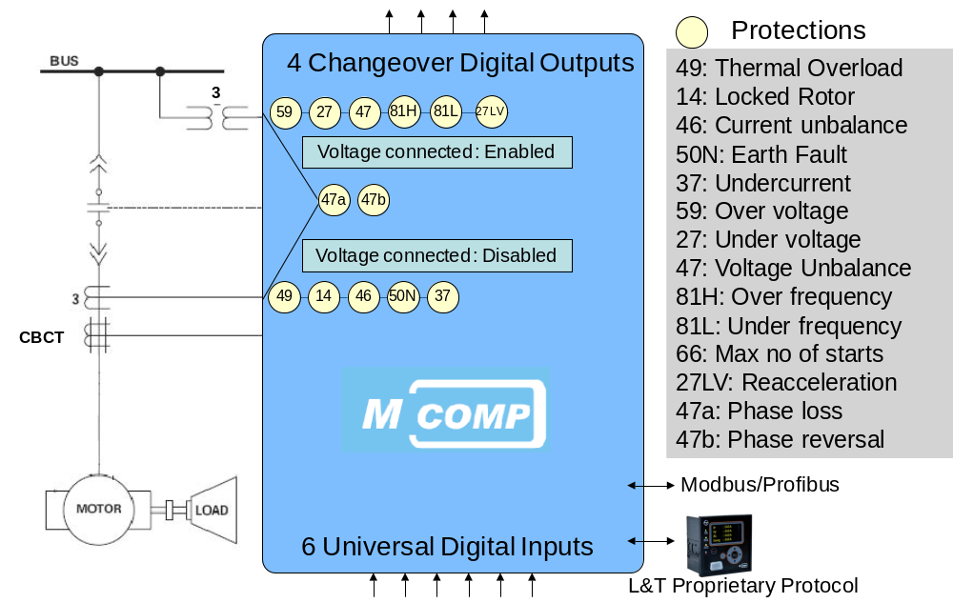
Fig 2.1 Protection functions of MCOMP relay
The metering parameters are as shown in the table below:
Table2.1 Metering Parameters
V,I | RMS value of voltage and current
Cosφ | Power Factor
I_{o} | Zero sequence current
KW, KVAR, KVA | Active, Reactive and Apparent power
KWH, KVARH, KVAH | Total Active, Reactive and Real Energies
Motor run hrs | No of hours motor has run since last start
Total motor run Hrs | No of hours motor has run since last factory restore
No of stops | No of times the motor has been stopped since last factory restore
Starting time | Time taken by the motor during starting condition
Starting peak current | Maximum current reached during starting condition
CT class detect | Type of CT connected
Phase sequence | RYB or RBY phase
Thermal Capacity | Percentage of maximum thermal limit
Indications
Motor Status, Alarm/Pickup Status and Trip Status
The MCOMP Main unit comprises of the two variants:

2.2.1 Modbus
Standard Modbus ports on Modicon controllers use an RS–232C compatible serial interface that defines connector pinouts, cabling, signal levels, transmission baud rates, and parity checking. Controllers can be networked directly or via modems. Controllers communicate using a master–slave technique, in which only one device (the master) can initiate transactions (called ‘queries’). The other devices (the slaves) respond by supplying the requested data to the master, or by taking the action requested in the query. Typical master devices include host processors and programming panels. Typical slaves include programmable controllers.
The master can address individual slaves, or can initiate a broadcast message to all slaves. Slaves return a message (called a ‘response’) to queries that are addressed to them individually. Responses are not returned to broadcast queries from the master. The Modbus protocol establishes the format for the master’s query by placing into it the device (or broadcast) address, a function code defining the requested action, any data to be sent, and an error–checking field. The slave’s response message is also constructed using Modbus protocol. It contains fields confirming the action taken, any data to be returned, and an error–checking field. If an error occurred in receipt of the message, or if the slave is unable to perform the requested action, the slave will construct an error message and send it as its response.

The Query: The function code in the query tells the addressed slave device what kind of action to perform. The data bytes contain any additional information that the slave will need to perform the function. For example, function code 03 will query the slave to read holding registers and respond with their contents. The data field must contain the information telling the slave which register to start at and how many registers to read. The error check field provides a method for the slave to validate the integrity of the message contents.
The Response: If the slave makes a normal response, the function code in the response is an echo of the function code in the query. The data bytes contain the data collected by the slave, such as register values or status. If an error occurs, the function code is modified to indicate that the response is an error response, and the data bytes contain a code that describes the error. The error check field allows the master to confirm that the message contents are valid.

2.2.2 Profibus
Fieldbus is a digital communication bus line connecting the field instruments with the control system components. . PROFIBUS is a short form for PROcess FIeldBUS and is a vendor-independent, open fieldbus standard. The PROFIBUS uses the IEC 1158-2, RS-485 or Fiber Optic technology. With the new PROFInet, the PROFIBUS will open up for the communication on Ethernet.
The figure below gives the profibus overview:
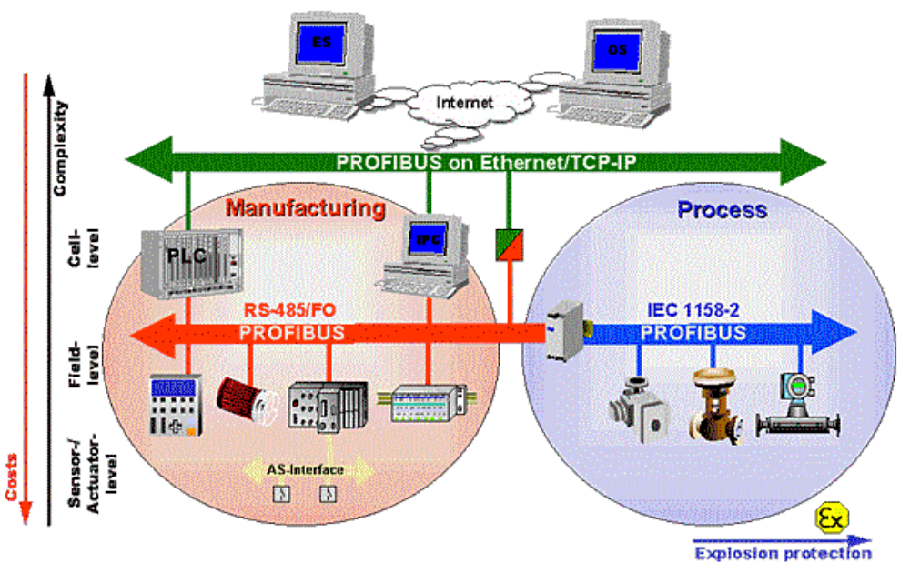
Fig 2.2 Profibus overview
The following variants have been specified for different applications
- PROFIBUS-FMS (Fieldbus Message Specification),
- PROFIBUS-DP (Decentralized Periphery), and
- PROFIBUS-PA (Process Automation).
DP Features
- DP communication is permanent and cyclic
- The transmitted data is specified during the configuration (optimized data exchange)
- Only one master can write outputs (safety aspect)
- Data can be read by controlling and Class 2 master
- Acyclic data via DPV1 functions
- Alarm acknowledgment
- Fastest fieldbus system (up to 12 MBaud)
- Up to 244 byte input AND 244 byte output data per station.
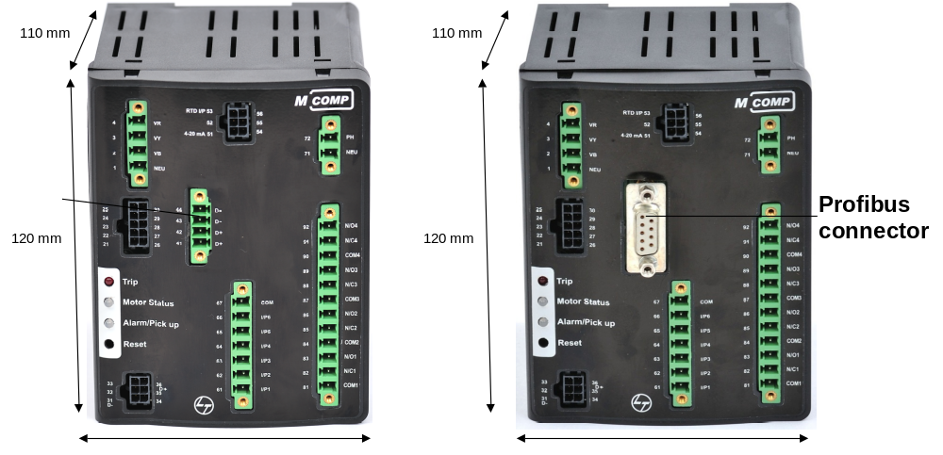
Modbus connector
Fig 2.3 MCOMP relay with Modbus and Profibus connectors

2.3 Omicron
A much more versatile way of testing is to inject the currents for all test object ends in order to simulate full primary system connection. This is the standard procedure for testing transformer differential relays with modern test equipment delivering e.g. 6 test currents, allowing full freedom to move around in the diff/bias characteristics plane, thus verifying all settings related to the characteristic. If you have local access to all line differential relays for one protected section, e.g. before mounting them on site, you can of course set up a test in the same way, i.e. set up the communication between the relays via a short local link and inject all required currents with one test device (e.g. CMC 256-6), see Fig2.4.
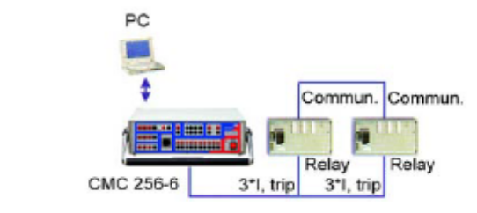
Fig 2.4 Local multi-end test injection

2.4 RS232↔ RS485 converter
The RS232/RS485 converter allows to interface any device using an RS232 serial link to an RS485 link. The RS485 link was conceived for long haul data acquisition and control applications. The original specifications (which have been surpassed by present hardware), allowed to network up to 32 stations on the same lines, at speeds up to 10 Mbits/s to distances of 4,000 feet (1200 mt). The link is balanced so that any electrical noise getting into one of the lines also gets into the other line thus allowing the receiver to cancel both noise signals. RS485 links are much used in industrial process control where reliability is important. Also, the ability to communicate over a long distance at a high speed is important when it comes to industrial plants where the stations might be spread over a large area. It is very common to have a PC in charge of controlling a given process.
PC's in general have an RS232 serial port (COM port) and therefore there are two solutions to link the computer to an RS485 network: One is to plug an RS485 interface in a computer slot and the other is to convert the RS232 level signal coming out the computer serial port into an RS485 signal. This is what the RS232/RS485 converter does. The converters are designed to work with the RMV Electronics general purpose I/O-485 line of stations specifically built for process control but they can also be used back to back thus providing an RS232/RS485/RS232. This way, two computers or devices using a standard RS232 serial port can communicate with each other at a maximum of 115200 Bauds over a distance of 4000 feet, something impossible to achieve using an RS232 link. One interesting application for using two RS232/RS485 converters back to back is when a computer needs to be connected to an I/O-232 board at a distance longer than usual. This provides very good performance while keeping the simplicity of our I/O-232 line of boards.

2.4.1 CONNECTION TO THE COMPUTER
The converter has a 9 pin DB9 connector of which only 3 lines are used: TX, RX and Ground. Some commercial cables have "straight" data lines whereas others are "crossed" (null modern). In order to accommodate both types, H1 and H2 allow to get a straight or a cross connection to the TX and RX lines. No RTS or other control lines are used since the link is fully duplex.
Experiment 1: To check the protection parameters of the MCOMP relay.
Pickup-100%Iflc
Alarm-110%
Trip cause-overcurrent
External CT: enable
Ratio- 100:1
Table 2.2 Overcurrent record table
Sr. No | CURRENT  INJECTED |  |  | OBSERVATIONS |  |  | RECORDS - TIME
Sr. No |  |  |  | MCOMP Suite |  |  | Pickup | Trip | Difference
 | Ir | Iy | Ib | Ir | Iy | b | (hr:min:sec:msec) | (hr:min:sec:msec) | (second)
 | (A) | (A) | (A) | (A) | (A) | (A)
1 | 3 | 1 | 0 | 301.8 | 102.6 | 0 | 14:35:7:940 | 14:35:8:060 | 0.1
2 | 2 | 1 | 0 | 200 | 100 | 0
3 | 2.1 | 1 | 0 | 208.6 | 102.8 | 0 | 14:38:55:160 | 14:38:55:280 | 0.01
4 | 2.01 | 1 | 0 | 201.5 | 102 | 0 | 14:45:52:600 | 14:45:52:720 | 0.01
5 | 2.001 | 1 | 0 | 201.1 | 101 | 0 | 14:51:12:280 | 14:51:12380 | 0.01
6 | 2.002 | 1 | 0 | 202 | 101 | 0 | 14:54:39:180 | 14:54:6:440 | 0.01
7 | 2.003 | 1 | 0 | 201 | 101.2 | 0 | 14:59:29:860 | 14:59:30:00 | 0.018

Pickup-50%Iflc
Alarm-110%
Trip delay-10 sec
Trip cause-Undercurrent
External CT: enable
Ratio- 100:1
Table 2.3 Undercurrent record table
Sr. No. | CURRENT INJECTED |  |  | OBSERVATIONS |  |  | RECORDS - TIME
Sr. No. |  |  |  | MCOMP Suite |  |  | Pickup | Trip | Difference
 | Ir  (A) | Iy  (A) | Ib  (A) | Ir | Iy | Ib | (hr:min:sec:msec) | (hr:min:sec:msec) | (sec)
 | Ir  (A) | Iy  (A) | Ib  (A) | (A) | (A) | (A)
1 | 1.38 | 1.8 | 0 | 139.3 | 181.4 | 0
2 | 1.1 | 1.85 | 0 | 110.7 | 179.6 | 0 | 15:12:43:780 | 15:12:43:780 | 0
3 | 1 | 1.8 | 0 | 101 | 179.8 | 0 | 15:17:48:780 | 15:17:58:780 | 10
4 | 1.8 | 1.1 | 0 | 181.3 | 110.3 | 0 | 15:24:47:820 | 15:24:57:840 | 10
5 | 1 | 1.8 | 0 | 101.8 | 179.8 | 0 | 15:28:14:540 | 15:28:24:440 | 10
6 | 1.1 | 1.8 | 0 | 112 | 184.3 | 0 | 15:31:53:880 | 15:32:3:780 | 50

Trip cause-Thermal overload
External CT: enable
Ratio- 100:1
Table 2.4 Thermal overload record table
SETTINGS |  | RECORDS - TIME
Pickup | Inhibit Status | Pickup | Trip | Difference
 |  | (hr:min:sec:msec) | (hr:min:sec:msec) | (sec)
100% | 33% | 15:54:3:520 | 15:54:3:520 | 0

Chapter3 MiCOM Relay

The protection device is designed to protect three-phase motors against: overload, short-circuit fault (phase-to-phase, rotor stall), earth fault, underload (e.g. no-load running of a pump), current unbalance of feeders, operation with a phase loss and overheating. It can control a circuit-breaker or contactor. Thanks to communication port implemented in the relay, it can exchange information with a supervisory system in terms of measurements, relay state, switches control, etc.
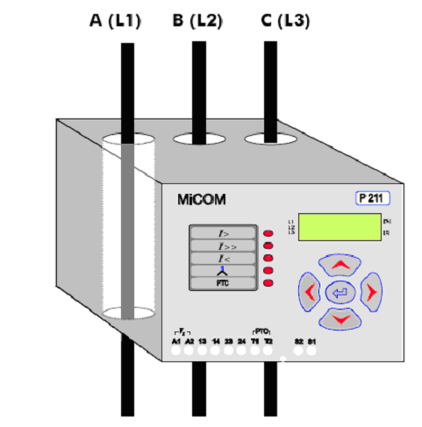
Fig 3.1 MiCOM relay
3.1 Modscan
ModScan32 is a Windows shareware application which operates as a MODBUS master. It allows you to access and change data points in a connected slave device using either the RTU or ASCII Transmission mode. ModScan32 is ideally suited for quick and easy compliance testing of the MODBUS protocol and its built-in display of serial traffic allows effective troubleshooting of field connections. ModScan is a Windows application designed to operate as a MODBUS Master device for accessing data points in a connected PLC compatible slave device. It is designed primarily as a testing device for verification of correct protocol operation in new or existing systems. MODBUS data points, coils and registers, may be read and/or written from the ModScan application using MODBUS Commands 01-06.
The basic operation of the application is depicted in the typical Windows display below:
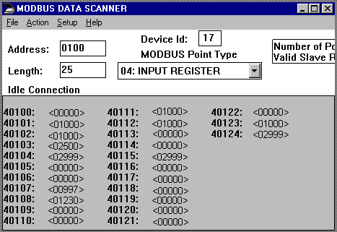
Fig 3.2 Modscan window
Experiment 2: Testing of the MiCOM relay
Table 3.1 Testing of the MiCOM relay using Modscan
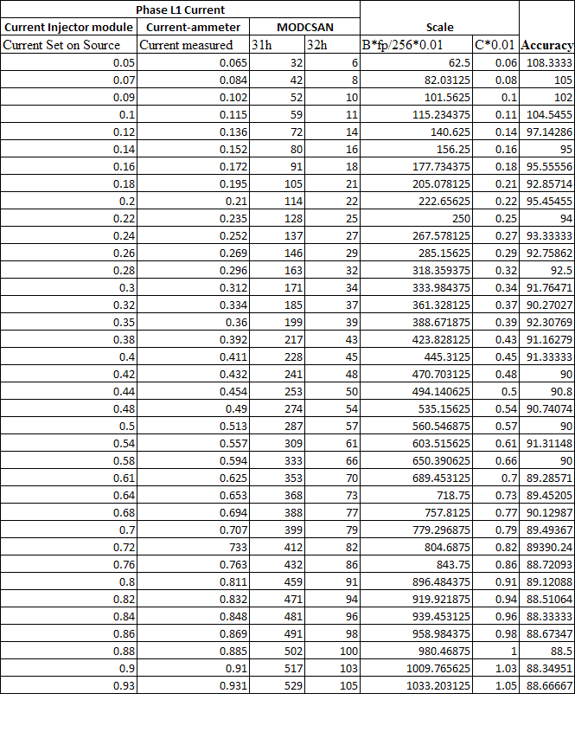

Chapter4 DAP HMI
One of the eight applications available within the DAPstudio™ suite is the DAPviewer™. The DAPviewer™ is a set of tools that allows the user to create a fully functional Human-Machine Interface (HMI) system while working within DAPstudio™. The DAPstudio™ tools have direct access to all of the points configured in the system and, as a result, there is no need to import external point lists.
DAPviewer™ features three viewer modes:
- WEB HMI in which the HMI is viewed and controlled over an Internet connection between the DAPserver™ and a remote computer
- Local HMI in which a terminal, mouse and keyboard are connected to a DAPserver™ and the HMI is accessed directly
- Stand Alone HMI
The main components of DAPstudio™ screen are:
- HMI Configuration Menu
- Menu Bar
- Working Area
- Drawing Toolbox Window Including:
- Basic Graphic
- Frame Window
HMI configuration
The HMI Configuration menu contains all of the HMI instances created by the user. A maximum of three HMI instances can be created here. Each HMI instance can have several windows. To create a new window, left click on Windows in an HMI instance then right click. Using the basic graphic objects and system frames provided by DAPviewer™, the user can draw various types of diagrams or tables and associate system points with them.

Experiment3: To configure a simple single line diagram, a navigation panel, trending curves and a monitor window.
Procedure: Initial setup
- Create a new project
- Go to device information and change model name to DAP-100.
- Now go to client application
- Change the stop bits to 2 (as we are using MCOMP relays).
- Initialize the device bus for the 3 MCOMP relays.

Procedure for Creating a HMI:
- Go to DAPview application.
- Creating a new HMI: Right click on the DAP HMI icon and click on New HMI option in the popup menu.
- Creating a new window: Expand the HMI instance tree, Select Windows and Left click on the new window.
- Draw the required figures and give appropriate animations by linking the graphics and the text to the respective links in the client application.

Single Line Diagram
All the three MCOMP relays are connected in a serial manner to the data concentrator. Current is injected using a current source via a current transformer. The parameters like power factor , phase sequence , trip cause , DI and DO status will be displayed in the text output boxes when the HMI is running as shown in the figure below.
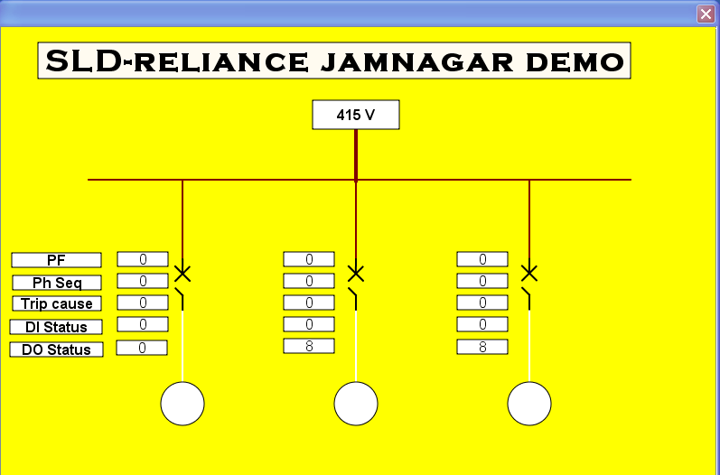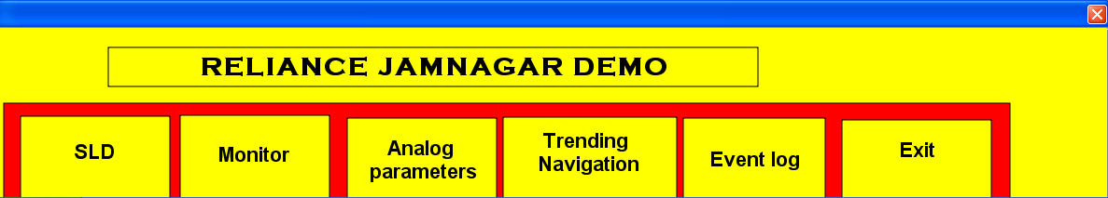
Fig 4.1 Single Line Diagram
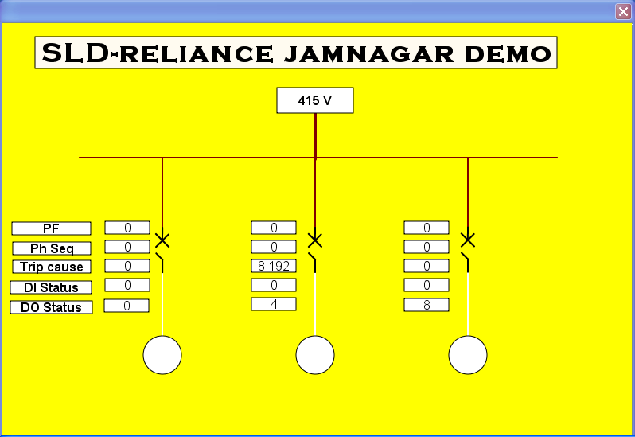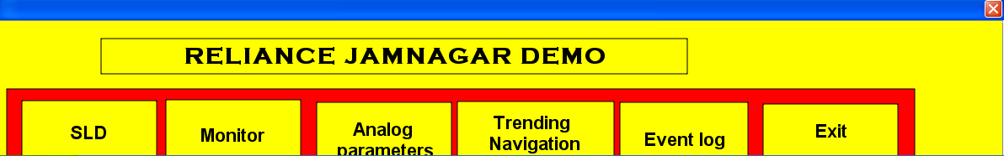
Fig 4.2 SLD window when MCOMP 2 is in trip state

Monitor and Control Window
Through this window we can control the three motors i.e. we can start , stop or reset them. We can also view various indications like alarm status , motor status, pickup , trip status and inhibit mode.
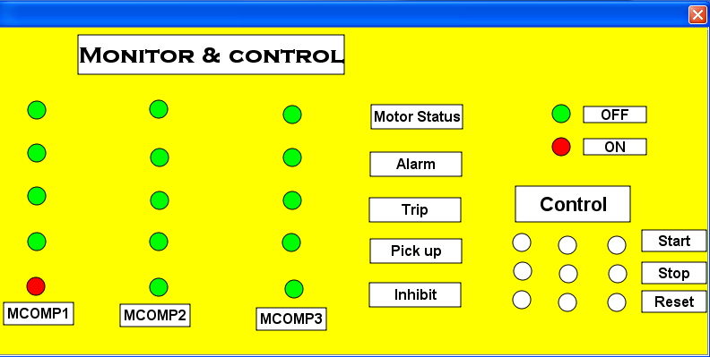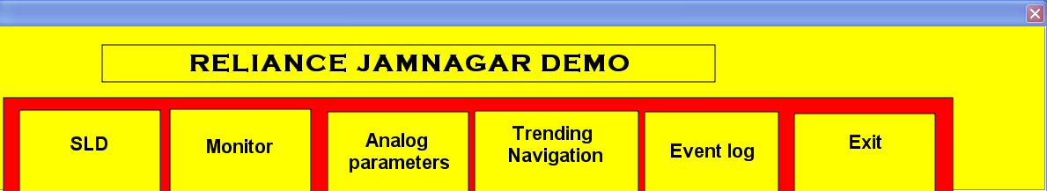
Fig 4.3 Monitor and control window
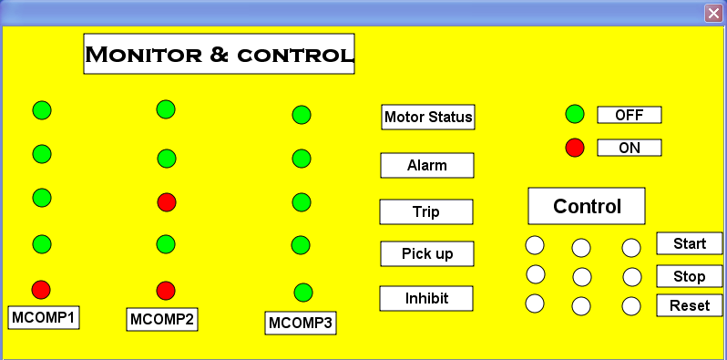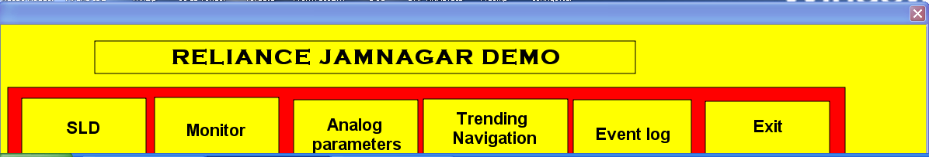
Fig 4.4 Monitor and control window when the MCOMP is in trip state
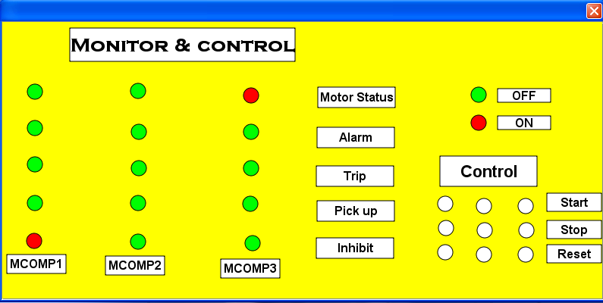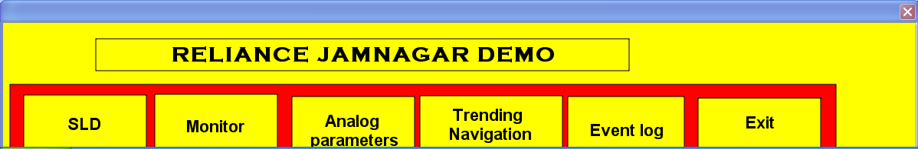
Fig 4.5 Monitor and Control window when MCOMP 3 is in the running state
Analog Parameters
It consists of an animated switch symbol which is made using the Bezel curve tool. The motor status (DI link) is given to the switch so that when the motor is turned on the switch is connected else it remains open. It will display the currents , voltages and frequency values.
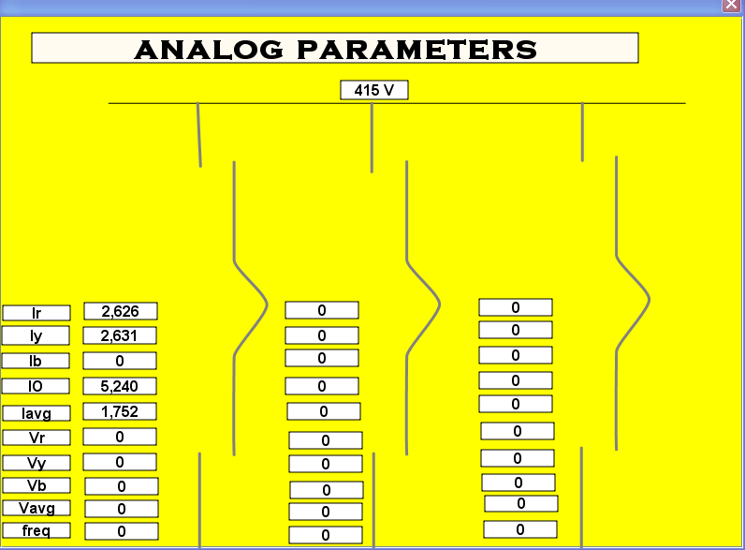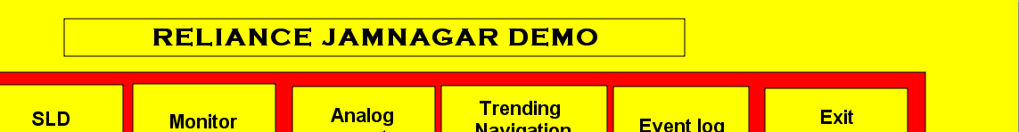
Fig 4.6 Analog parameters window
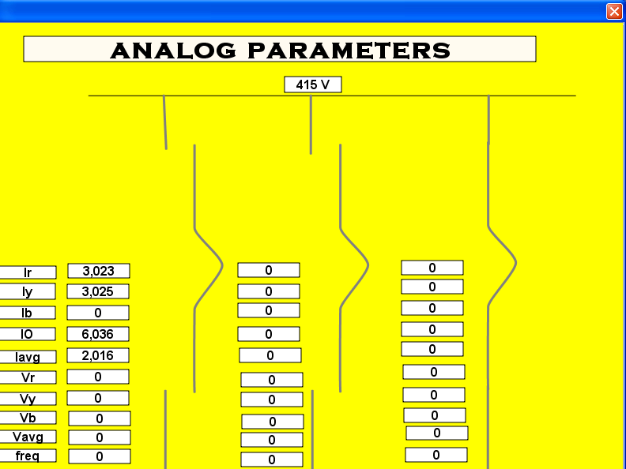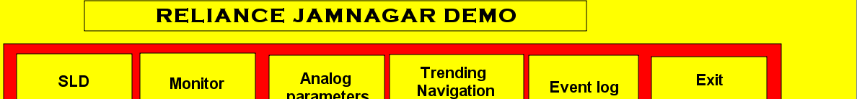
Fig 4.7 Analog parameters when MCOMP 3 is in running state

Event log table
The following table will give a detailed information of the events that occurred while working on a HMI.it shows the last login time , the controlling action performed on the motors(ON/OFF).
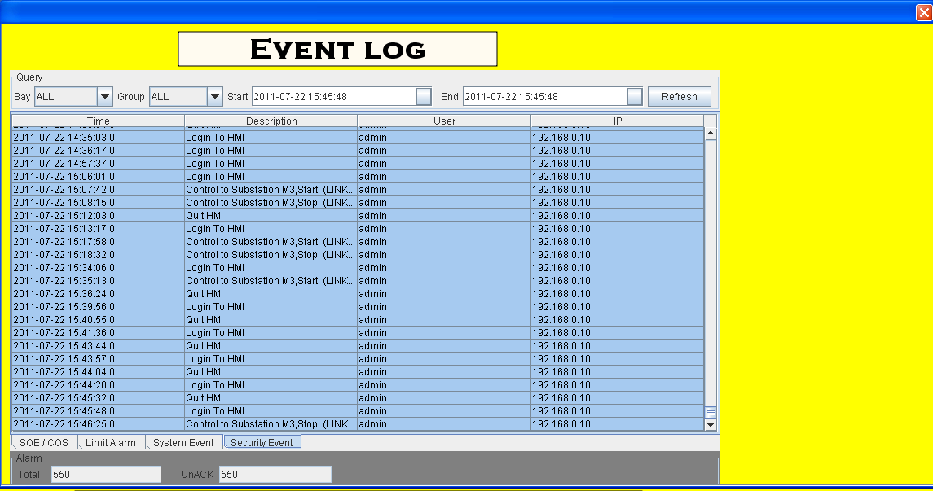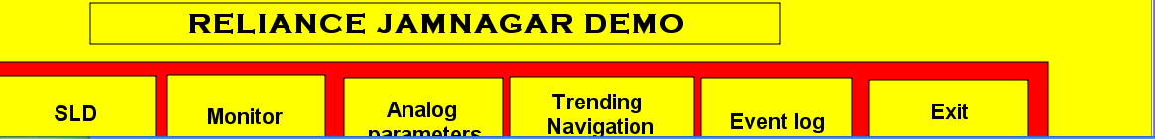
Fig 4.8 Event log window
Trending Curve
The Trending Curve table displays changes in analog input values in a graphical format. The R-phase voltage/current, Y-phase voltage/current , B-phase voltage/current will be shown when respective voltage/current is injected.

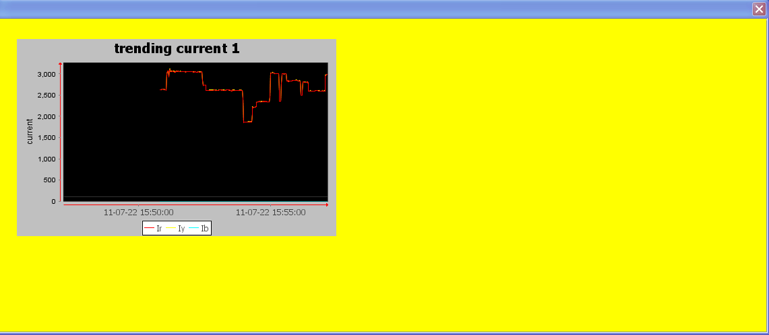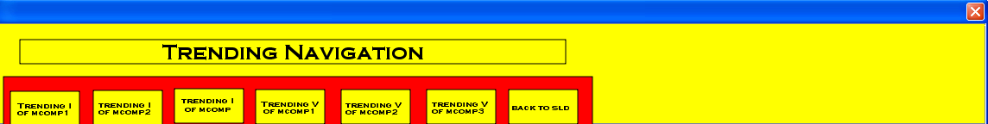
Fig 4.9 Trending Current window
Navigation Window
Since we have more than two windows we will configure a window that will allow navigation between the windows. The steps to be followed in configuring a navigation window is as follows:
- Create a new window and name it “Navigation”.
- Select the window by right clicking on it and then right click to gain access to its properties.
- In the Type drop down list, choose Replace.
- Create boxes with names (Text boxes) corresponding to the windows that need to be navigated.
- Double click on the text box, expand the Operation tree and choose Open Window.
- Use the add button and choose the respective windows along with navigation window.
- Select Operation and right click to define the function of the left mouse button for this object. From the drop down list, choose Open Window.
- Double click in the Exit window, expand the Operation tree and choose Execute Command. From the drop down list, choose Quit System. Under Authority, choose one user.
- To see the trending curve, double click on the trending textbox, expand the operation tree and go to open window. Give the required links in the associate trending tag.

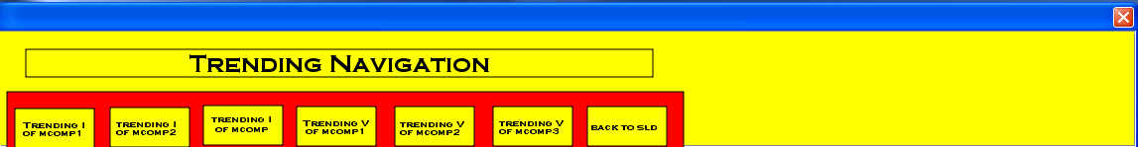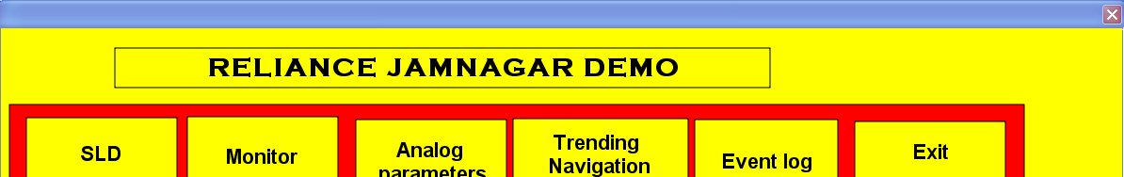
Fig 4.10 The two navigation windows
Exit Window
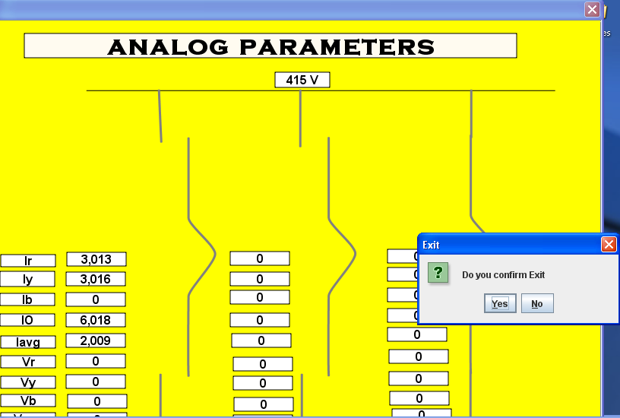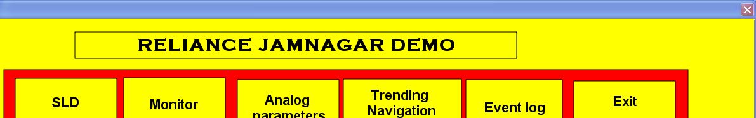
Fig 4.11 Confirming exit window

Chapter5 Conclusion
We are very thankful to Larsen and Toubro for giving us the opportunity to work amongst the team. With these projects we got the chance to know the Switchgear products, the organizational structure of L&T, activities performed by the EGB Department of L&T and its distribution channel.

